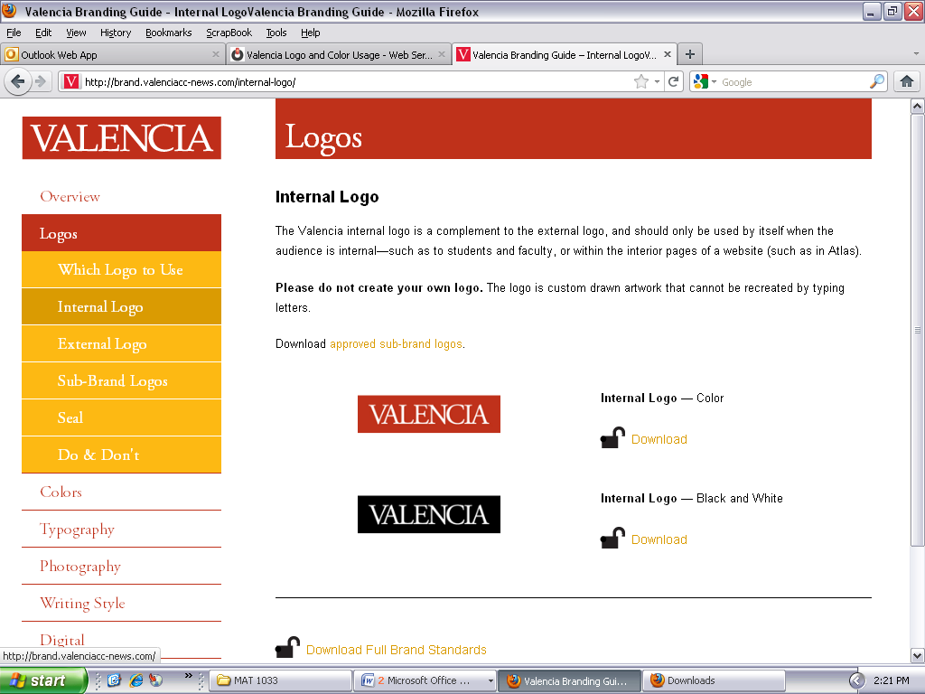

**INSTRUCTOR’S Information/Contact:**

**Montez Bates**

**Course Information:**

|  |
| --- |
| **CRN:** 18151 **Location:** 7-207 **Class Meetings:** T/R 5:30 PM – 7:10 PM **Lab Meetings:** 50 minutes per week |

**Contact Information:**

|  |  |
| --- | --- |
| **College General Phone Number** | (407) – 299 – 5000 |
| **College Website** | [www.valenciacollege.edu](http://www.valenciacollege.edu) |
| **Math Department Phone Numbers** | (407) – 582 – 1625 **OR** (407) – 582 – 1848 |
| **Instructor’s Phone Number** | (407) – 582 - 1757 |
| **Instructor’s E-mail** | mbates5@valenciacollege.edu |
| **Instructor’s Office Hours Location** | 7-253 |

**NOTE: T/R is Tuesday and Thursday**

**Office Hours:**

|  |  |
| --- | --- |
| **Days** | **Times** |
| **T/R** | Before class: 5:00 – 5:30 PM |
| **Other times** | By appointment |

**Course Objective & Description:**

**Course Description:**

This developmental math course is designed to prepare students for MAT 1033C Intermediate Algebra. Topics include sets, computations with decimals, percents, integers, operations with rational and polynomial expressions, solving linear equations and simplifying expressions, plane geometric figures and applications, graphing ordered pairs and lines and determining the intercepts of lines. A minimum final course grade of C is required for successful completion of this course. This course does not apply toward mathematics requirements in general education or toward any associate degree. (Special Fee: $42.00)

**Prerequisites:** NONE **Credits:** 4

**Valencia Core Competencies:**

This course seeks to reinforce the following Valencia Student Competencies:

* **Think** clearly, critically and creatively by analyzing, synthesizing, integrating and evaluating symbolic works and truth claims.
* Reflect on your own and others’ **values** from individual, cultural and global perspectives.
* **Communicate** by reading, listening, writing and speaking effectively.
* **Act** purposefully, reflectively and responsibly by implementing effective problem solving and decision making strategies.

**Valencia Developmental Math Combined Competencies:**

Valencia College students are expected to possess and demonstrate the following competencies:

* Operations with Rational and Polynomial Expressions
* Linear Equations with Application
* Introduction to graphing linear equations
* Geometry
* Sets
* Radicals
* Unit Conversion
* Operations with Fractions/Decimals
* Long Division/Multiplication Facts
* Simplifying algebraic expressions and order of operations

**Required Materials:**

**1) MyMathLab software access code:**

You must purchase a MyMathLab Course Compass student access kit from the bookstore or on-line at [www.pearsonmylabandmastering.com](http://www.pearsonmylabandmastering.com). A Course ID is required and is listed in your Blackboard account. Be sure to enter the course ID that corresponds to the course you are enrolled in. Students will be granted access to the software without paying for a period of 14 days. After the 14 day grace period, access will be blocked until the student enters a valid access code.

*Note: Students who have taken this course within the last semester on the West Campus and are repeating this course do NOT have to purchase the MyMathLab access as long as the same username/password from the last semester is used. This applies to students who have previously paid for the software and received a grade of D, F, or W in the last semester only. For registration difficulties, contact Nick Navarro or Aditi Batra in the Math Open Lab (Building 7, Room 241) on the West Campus.

**2) MAT 0022C Notebook/Portfolio (Instructor’s discretion):**

A 3-ring binder (3 inches recommended) with 5 subject dividers and pockets.

**3) Course syllabus, Open Lab Syllabus, and Math Learning Plans (9 copies):**

These documents can be obtained through Blackboard or the Math Center’s website (West Campus ONLY).

**4) Basic or scientific calculator:**

Some assignments will require the use of a calculator. The use of a calculator will be very limited in this course and might be used on some activities and homework assignments. Although calculators may not be used daily, calculators are available for check-out as well. Financial aid may cover part or the full cost of your calculator. **Cell phones CANNOT be used as calculators!**

**Recommended/Additional Resources:**

*Integrated Arithmetic and Basic Algebra*, Jordan/Palow, 5th edition. Pearson, 2011. Older editions of the book are acceptable. Please note that you have access to the entire book through MyMathLab in the multimedia section. This is included in the cost for MyMathLab software. ISBN: 9780321747389

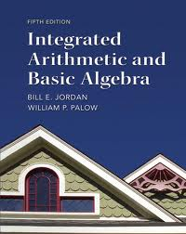

**College-Wide Resources:**

Valencia College provides many resources for extra help in your courses. Take advantage of these resources.

### Valencia's Math Help 24/7: www.valenciacollege.edu/math/liveScribe.cfm

Valencia Math professors have created pen-casts and videos of common lessons to aid your learning.  Click on **Developmental Math I or II** to expand the topics.  Some lessons have more than one professor's perspective, so don't hesitate to watch more than one!

### Khan Academy: www.khanacademy.org

The Khan Academy has video lessons on developmental math topics (and many other academic topics!) as well as interactive learning tools.  You can create an account if you want to save your progress.  Or to get started, just click **Learn** in the top left corner of the home page.  For video lessons, click Expand topic list - - > Algebra I or Arithmetic/Pre-Algebra**.**For interactive practice, click **Knowledge Map** and navigate the knowledge map using the zoom and scan tools in the top left corner of the map.

* **Math TV:** **www.mathtv.com**

Pat McKeague delivers quick video lessons on many algebraic topics.  Just click the subjects on the left to expand the lists of topics.

**SmarThinking by Pearson:**

Smarthinking is the free online tutoring tool for Valencia’s students. You can access Smarthinking through the Courses tab in Atlas. Smarthinking is best used as a back up to on-campus services and support, not a replacement. Directly above the Smarthinking link in Atlas is a link to Learning Support’s website, a great place to check for campus-based information (<http://valenciacollege.edu/learning-support/>).

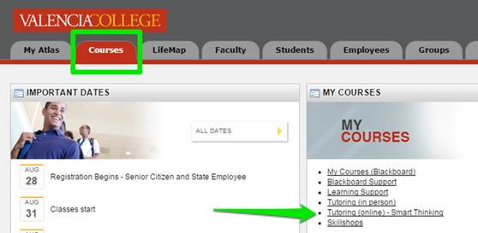

**Math Center Resource Information (West Campus):**

The Math Center is located in Building 7 on the second floor and includes rooms 240-257. The Math Center houses the Math Open Lab in 7-241 for developmental math students who work on their required lab assignments in the presence of Lab Instructors, Math Connections for tutoring and assistance, and Hands-On Math Lab for interactive workshop and reviews.

Math Connections is available for groups or individuals to practice skills with resource worksheets or review class materials.  Math Connections is located in Room 255 (access through the Math Center). Visit <http://valenciacollege.edu/west/lss/math/mathconnections.cfm> for more information.

The Hands-On Math Lab offers interactive assistance with manipulatives and concept workshops throughout the semester.  The Hands-On Lab is located in Room 256 (behind the hole in the wall in the Math Center). Visit  <http://valenciacollege.edu/west/lss/math/handson.cfm> for more information.

Peer tutors in the Math Center are available for walk-in assistance.  Ask for additional details at the Information Desk in the Math Center.

**Math Center Hours & Open Lab (Building 7, Room 241):**

|  |  |
| --- | --- |
| **Days** | **Times** |
| **Monday – Thursday** | 8:30 AM – 7:30 PM |
| **Friday** | 8:30 AM – 6:30 PM |
| **Saturday** | 10:00 AM – 3:00 PM |
| **Sunday** | CLOSED |

**Math Connections (Building 7, Room 256 – right hand side behind computer lab):**

|  |  |
| --- | --- |
| **Days** | **Times** |
| **Monday – Thursday** | 9:00 AM – 7:30 PM |
| **Friday** | 9:00 AM – 1:00 PM |
| **Saturday** | CLOSED |
| **Sunday** | CLOSED |

**\*NOTE:** *Hours subject to change. Check with the Math Center for updated changes and/or closures throughout the semester.*

**Lab Contact Information:**

|  |  |
| --- | --- |
| Aditi Batra (Lab Supervisor) | (407) – 582 – 1780 |
| Nicolas Navarro (Lab Supervisor) | (407) – 582 – 1720 |
| Math & Tutoring Center Information Desk | (407) – 582 – 1633 |

**Class policies:**

**Attendance:**

* You are expected to attend every class meeting, unless an illness or emergency makes it impossible for you to do so.
* Absences are excused solely at the discretion of the instructor. Proof of the existence of extenuating circumstances must be shown for any absence(s) to be excused.
* You are responsible for any information and/or assignments given during class, whether or not you are present.
* In-class activities can’t be “made up.”
* Your success in class is directly related to attendance and participation. If you must miss class, please send an email. It is your responsibility to request and/or copy any handouts, assignments or class notes from a reliable classmate. Even if you are absent, you are responsible for submitting any assignments due that day, either through Blackboard or submitted BEFORE the next class meeting time.
* You are expected to be in class on time, and to remain in class for the entire period unless permission to leave early has been granted by the instructor. It is disruptive to arrive or depart while class is in session.
* Being late three times fifteen minutes or more will count as an absence. Acceptable reasons for absence given in advance may be excused.
* **Excessive absences (more than 3) will lead to poor performance in the course and may lead to a withdrawal by the professor. Students who are excessively absent may not be permitted to make up examinations and must take full responsibility for any class material that is missed.**

Policy Website Link: [http://valenciacollege.edu/generalcounsel/policy/ValenciaCollegePolicy.cfm?policyID=75](http://valenciacollege.edu/generalcounsel/policy/ValenciaCollegePolicy.cfm?policyID=75%20)

**Available Resources and Assistance:**

* Ask questions regularly and see me for extra help as needed. I am interested in your success in this class and only consider myself successful if you are successful. Please do not hesitate to ask for assistance. You can meet with me during office hours, make an appointment, e-mail me, or call me.
* Use all of your resources if you need help. This includes meeting with your SL leader (if available for your class) and going to the math lab for tutoring on your campus.
* Form study groups or find a study buddy. Working with fellow classmates can foster learning and understanding of the material as well as help you throughout the semester.

**Conduct:**

* You are encouraged to actively participate and ask pertinent questions during class. Courtesy will be observed at all times.
* Your attitude will greatly affect your ability to succeed in this course. It will also affect your classmates’ attitudes should you choose to participate in class discussions. Always consider this carefully before you speak or act.
* Cell phones, pagers, or other electronic devices that are audible are not permitted to be on during class. Unplug yourself and make the most of class time! Personal electronic devices disrupt your learning as well as the learning of other students.
* If there is an emergency situation warranting the use of a cell phone or pager during class time, the student must notify the professor in writing prior to the beginning of class. During a testing situation, if a cell phone or pager vibrates or is audible, the student’s quiz, test, or examination may be collected by the professor and the student may be asked to leave without an option for completion.
* Computers are not allowed in the classroom unless otherwise approved by the Office for Students with Disabilities.
* To create a learning environment, please avoid sidebar conversations with other students. Rude comments or remarks, raised voices or confrontational comments are not permitted while work is being done at the board. Follow the instructions given by your instructor, who serves as your classroom manager.
* If your actions in class are deemed by your instructor to be disruptive, you will be asked to leave class immediately. If you are asked to leave class, you **may** be permitted to return to future class meetings after consultation with your instructor outside of class. You may also be required to arrange a conference with another college official before attending class again.
* You will find more information about the Student Code of Conduct in the current Valencia Student Handbook. For more information about Valencia’s Student Code of Conduct, visit <http://catalog.valenciacollege.edu/academicpoliciesprocedures/studentcodeofconduct/>.

**Tips for Success:**

* Read the section of material each week in the textbook before class. When you read the sections, work out the textbook practice problems/examples with pencil and paper. You should try to complete these practice problems/examples before moving on to the homework. When doing homework, check your answers and redo the problems that are incorrect. Get help with problems that you are struggling with.
* Watch the useful media, videos, read the sections, and take notes before coming to class. Previewing the material will help you prepare for the upcoming class.
* Work through homework problems and bring questions/concerns with you to class.
* Come to class on-time and ready to learn. Don’t miss lab time.
* If you do not do any prep work (reading the text, practice problems, watching the useful media) before attempting the homework assignments, then you may have a rough time.
* Don’t wait until the deadline to start working. Spread out the work over several days. This will help you learn the material better. Don’t rely on the “watch it” help buttons, make sure that you are trying to learn how to do the work yourself or you may have a rough time on the exams.
* Always pass (not just take) a practice exam before you take your real exam.
* Manage your time and make a weekly schedule where 2 to 3 hours is set aside regularly for your math work/lab work beyond class time and your assigned lab time.

**Academic Honesty:**

* **Plagiarism or cheating of any form will be cause for immediate removal from this class, a course grade of F, and referral of the incident to the Dean of Student Affairs/Mathematics.** Cheating is defined by any behavior that can be construed as cheating such as blatant cheating, looking at somebody’s paper, talking or whispering during a test, copying (including all take-home activities, examinations, and/or homework assignments), use of a cellular phone or other electronic device without prior permission, suspicious behavior, or failing to follow appropriate procedures for taking a test as prescribed by the instructor. **SIMPLY stated, cheating will not be tolerated.** Policy Website Link: <http://valenciacollege.edu/generalcounsel/policy/ValenciaCollegePolicy.cfm?policyID=180>

**Withdrawal Policy:**

The deadline to withdraw from class with a grade of “W” is **November 13, 2015** (11:59 PM on atlas) for full-term classes**. After the deadline, students will NOT be able to withdraw and will receive the grade earned according to the instructor’s grading policy.** Students taking this course for the third time cannot withdraw after the add/drop period (first week of classes) – they must receive an actual grade per state and college policy. A student with excessive absences (more than 3) may be withdrawn by the instructor at the instructor’s discretion. A student that is withdrawn will receive a grade of “W”.

Policy Website Link:<http://valenciacollege.edu/generalcounsel/policy/ValenciaCollegePolicy.cfm?policyID=75>

**Grading Policy:**

|  |  |
| --- | --- |
| **Requirements** | **Percent Weight** |
| In-class exams | 50% |
| Lab Component | 15% |
| HW/Notebook | 10% |
| Comprehensive Final Exam | 25% |
| **TOTAL for course:** | **100%** |

**Exams:**

You will have several examinations throughout this course. They may be a combination of short answers and/or multiple choice. Partial credit is given solely at your instructor’s discretion. The best way to prepare for exams is to do the homework assigned by your instructor. Exams are worth 50% of your course grade.

**Lab Component:**

In order to maximize your learning experience, lab assignments have been designed to reinforce concepts learned in class and complement your course work. This class has a required lab component that counts for 15% of your course grade. A minimum of 50 minutes is required to be spent in the Math Open Lab each week.  You must work on your lab homework and lab quizzes during your time in the Math Open Lab. Each lab quiz requires a grade of 70% or higher for completion of the lab assignment.

**Homework and Notebook:**

You will be required to maintain an organized notebook which should include your class notes, completed homework assignments, lab assignments, activities, your returned exams with corrections completed, and a section for reviews and miscellaneous. Your notebook is graded based on neatness, organization, work shown, diligence, and effort. Your completed homework assignments is a majot part of your notebook grade and is required for a passing notebook grade. Your instructor will provide more information about the grading of this component. Your notebook and graded homework is worth 10% of your course grade.

**Final Exam:**

The final examination in this course is **MANDATORY**. The final examination in this course is worth 25% of the final course grade. Any student who does not attempt the examination will receive a 0, which will impact the final average in the course.

The final exam is a cumulative exam given at the end of the course and can be taken ONLY once! This is a proctored, unassisted exam and the final exam grade CANNOT be dropped or replaced. There is no extra credit associated with the final exam. The final exam grade is based on the number of problems answered correctly!

**Grading Scale (Strictly Enforced):**

|  |  |
| --- | --- |
| **Percentage Scale** | **Course Grade** |
| 90.0% or higher | **A** |
| 80.0% – 89.9% | **B** |
| 70.0% – 79.9% | **C** |
| 60.0% - 69.9% | **D** |
| Below 60.0% | **F** |

**\*Notes:**

* All exam/quiz grades are rounded to the nearest whole number and final course grades are rounded to the nearest tenth of a percent.
* Students receive the grade they earn based on the course requirements and percentage grade earned.
* There are plenty of opportunities for success in this course if you take this course seriously!

**Other Policies & Information:**

**Make-Up Policy (Instructor’s discretion):**

There are **NO make-up examinations or late work accepted** unless you are absent due to a legitimate reason approved by the instructor or a valid emergency circumstance such as an illness or death in the family. Work obligations, child care, traffic conditions, or illness without documentation are not considered excused absences and make-up examinations/late work due to these reasons will NOT be permitted! All make-up examinations should be completed immediately upon return to class. **If your absent is unexcused or timely notice was not given, you will receive a zero for any missed tests, quizzes, or in-class assignments.** Late work is only accepted solely at your instructor’s discretion.

**Calculator Policy (Campus based/instructor’s discretion):**

**Calculators will NOT be allowed during exams (including the final examination).** Cell phones are not allowed to be used as calculators. If you plan on taking higher level math course, you may want to consider purchasing a TI-84+ graphing calculator. Calculators are NOT permitted for this course except for certain content in Chapter 3 & 8. Students should complete all homework, on-line assignments, and lab assignments without the use of a calculator unless otherwise directed. Students that inconsistently follow the calculator policy in the math lab will be given a 0 for their lab grade. Take this policy seriously.

**Computer/Equipment Use Policy:**

This course relies on the use of technology to aid in your learning. You are expected to check Blackboard and your e-mail at least once before class to ensure that you have the most current information. Computers are available on campus if you do not own one. If you experience any technical issues, call the support numbers below.

Blackboard Help Desk: (407)-582-5600 or [onlinehelp@valenciacollege.edu](mailto:onlinehelp@valenciacollege.edu)

OIT Help Desk: (407)-582-5554

**E-mail Communication Policy:**

The instructor will only correspond with you through your atlas e-mail. Students are expected to check their atlas e-mail daily. The instructor may send updates, announcements, changes, etc. to your atlas e-mail. Students are responsible for all messages sent to their atlas e-mail by the instructor. The instructor will not correspond with any other e-mail account, PDA, or cell phone. All e-mail correspondence must originate from your Valencia account. Grades are discussed by appointment only or through your atlas e-mail. All e-mail by students and the instructor should be respectful and professional. Students should identify their name, class that they are in, and a complete message using respectful language, complete sentences, and proper grammar. A subject line is mandatory.

**Valencia ID card:**

Your student ID card can be obtained in the Student Development office on any Campus once you have registered and paid for your classes. You will need your student ID card to access campus services such as the Library and Testing Center. The first student ID card is free. There is a $5 fee for a replacement card. Student IDs can be used for library access, testing purposes and discounts in the community.

**Valencia Student Core Competencies:**

The Valencia faculty has defined four interrelated competencies (**Think, Value, Communicate, Act**) that prepare students to succeed in the world community. These competencies are outlined in the College Catalog at valenciacollege.edu/catalog. In this course, through classroom lecture and discussion, group work, and other learning activities, you will further your mastery of those core competencies.

**Visitors:**

Children or other visitors are not allowed to be in class with you.

**Dress:**

If your dress (or state of undress) is such that it causes a distraction and disrupts the learning environment in my classroom, you will be asked to leave and to cover up or change your clothing before returning to class. Examples of such distractions include, but are not limited to, visible underwear, violent/graphic images, hate speech or images, and profanity.

**Special Accommodations:**

Students with disabilities who qualify for academic accommodations must provide a notification to Instructor (NTI) form from the Office for Students with Disabilities (OSD) and discuss specific needs with the professor, preferably during the first two weeks of class. The Office for Students with Disabilities determines accommodations based on appropriate documentation of disabilities. Contact information: West Campus SSB, Rm. 102 Phone: 407-582-1523 Fax: 407-582-1326 TTY: 407-582-1222 Policy Website Link:<http://valenciacollege.edu/osd/>

**Student Resource for Assistance:**

Valencia College is interested in making sure all students have a rewarding and successful college experience.  Valencia students can get immediate help with issues dealing with stress, anxiety, depression, adjustment difficulties, substance abuse, time management, relationships, or any other problems associated with school, home or work.  BayCare Behavioral Health Student Assistance Program (SAP) services are free to all Valencia students and available 24 hours a day by calling (800) 878-5470. Free face-to-face counseling is also available.